

|  |  |
| --- | --- |
|  | |
| **Name:** | Hanzla Jaffar |
| **Registration/ID** | S2018065042 |
| **Assignment** | LIST |
| **Submitted to** | Muhammad Asad Arshed |

**How logical address map with physical address?**

The logical address is mapped to its corresponding physical address **by a hardware device called Memory-Management Unit**. The address-binding methods used by MMU generates identical logical and physical address during compile time and load time.

**Comparison between logical and physical address**

|  |  |  |
| --- | --- | --- |
| **BASIS FOR**  **COMPARISON** | **LOGICAL ADDRESS** | **PHYSICAL ADDRESS** |
| Basic | It is the virtual address | The physical address is a |

generated by CPU location in a memory unit.

|  |  |  |
| --- | --- | --- |
| Address Space | Set of all logical addresses  generated by CPU in  reference to a program is  referred as Logical  Address Space. | Set of all physical addresses mapped to the corresponding logical addresses is referred as Physical Address. |
| Visibility | The user can view the | The user can never view |
| logical address of a | physical address of program |

**FOR**

**BASIS**

**COMPARISON**

**LOGICAL ADDRESS**

**PHYSICAL ADDRESS**

program.

Access

The user uses the logical

address

to

access

the

physical address.

The user can not directly

access physical address.

Generation

The Logical Address is

generated by the CPU

Physical Address is Computed

by MMU

# Definition of Logical Address

Address generated by **CPU** while a program is running is referred as **Logical Address**. The logical address is virtual as it does not exist physically. Hence, it is also called as **Virtual Address**. This address is used as a reference to access the physical memory location. The set of all logical addresses generated by a programs perspective is called **Logical Address Space**.

The logical address is mapped to its corresponding physical address by a hardware device called **Memory-Management Unit**. The address-binding methods used by MMU generates **identical** logical and physical address during **compile time** and **load time**. However, while **run-time** the address-binding methods generate **different** logical and physical address.

Definition of Physical Address

**Physical Address** identifies a physical location in a memory. MMU (**Memory-Management Unit)** computes the physical address for the corresponding logical address. MMU also uses logical address computing physical address. The user never deals with the physical address. Instead, the physical address is accessed by its corresponding logical address by the user. The user program generates the logical address and thinks that the program is running in this logical address. But the program needs physical memory for its execution. Hence, the logical address must be mapped to the physical address before they are used.

The logical address is mapped to the physical address using a hardware called **Memory-Management Unit**. The set of all physical addresses corresponding to the logical addresses in a Logical address space is called **Physical Address Space**.

# Key Differences Between Logical and Physical Address in OS

|  |  |  |  |
| --- | --- | --- | --- |
| 1. | The b | asic difference between Logical and physical address is that Logical address is generated by CPU in | |
|  | perspective of a program. On the other hand, the physical address is a location that exists in the memory unit. | |  |

1. The set of all logical addresses generated by CPU for a program is called Logical Address Space. However, the set of all physical address mapped to corresponding logical addresses is referred as Physical Address Space.
2. The logical address is also called virtual address as the logical address does not exist physically in the memory unit. The physical address is a location in the memory unit that can be accessed physically.
3. Identical logical address and physical address are generated by Compile-time and Load time address binding methods.

|  |  |  |
| --- | --- | --- |
| 5. | The lo | gical and physical address generated while run-time address binding method differs from each other. |

6. The logical address is generated by the CPU while program is running whereas, the physical addres is computed by the MMU (Memory Management Unit).

**Memory Allocation Techniques:**  
To store the data and to manage the processes, we need a large-sized memory and, at the same time, we need to access the data as fast as possible. But if we increase the size of memory, the access time will also increase and, as we know, the CPU always generates addresses for secondary memory, i.e. logical addresses. But we want to access the main memory, so we need Address translation of logical address into physical address.  
The main memory interacts with both the user processes and the operating system.So we need to efficiently use the main memory.Main memory is divided into non-overlapping memory regions called partitions.

The main memory can be broadly allocated in two ways –

1. [Contiguous memory allocation](https://www.geeksforgeeks.org/implementation-of-contiguous-memory-management-techniques/)
2. [Non-Contiguous memory allocation](https://www.geeksforgeeks.org/non-contiguous-allocation-in-operating-system/)

**Contiguous memory allocation can be categorized into two ways :**

1. [Fixed partition scheme](https://www.geeksforgeeks.org/fixed-or-static-partitioning-in-operating-system/)
2. [Variable partition scheme.](https://www.geeksforgeeks.org/variable-or-dynamic-partitioning-in-operating-system/)

**Different Partition Allocation methods are used in Contiguous memory allocations –**

1. [First Fit](https://www.geeksforgeeks.org/first-fit-allocation-in-operating-systems/)
2. [Best Fit](https://www.geeksforgeeks.org/best-fit-allocation-in-operating-system/)
3. [Worst Fit](https://www.geeksforgeeks.org/worst-fit-allocation-in-operating-systems/)
4. [Next Fit](https://www.geeksforgeeks.org/program-for-next-fit-algorithm-in-memory-management/)

**Non-Contiguous memory allocation can be categorized into many ways :**

1. [Paging](https://www.geeksforgeeks.org/paging-in-operating-system/)
2. [Multitlevel paging](https://www.geeksforgeeks.org/multilevel-paging-in-operating-system/)
3. [Inverted paging](https://www.geeksforgeeks.org/inverted-page-table-in-operating-system/)
4. [Segmentation](https://www.geeksforgeeks.org/segmentation-in-operating-system/)
5. [Segmented paging](https://www.geeksforgeeks.org/paged-segmentation-and-segmented-paging/)

**MMU(Memory Management Unit) :**  
The run time mapping between Virtual address and Physical Address is done by a hardware device known as MMU.  
In memory management, the Operating System will handle the processes and move the processes between disk and memory for execution . It keeps track of available and used memory.

**MMU scheme :**

CPU------- MMU------Memory

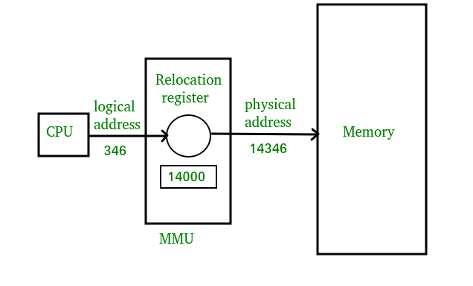

*Dynamic relocation using a relocation register.*

1. CPU will generate logical address for eg: 346
2. MMU will generate a relocation register (base register) for eg: 14000
3. In memory, the physical address is located eg:(346+14000= 14346)

The value in the relocation register is added to every address generated by a user process at the time the address is sent to memory. The user program never sees the real physical addresses. The program can create a pointer to location 346, store it in memory, manipulate it, and compare it with other addresses—all like the number 346.   
The user program generates only logical addresses. However, these logical addresses must be mapped to physical addresses before they are used.

**Address binding :**  
Address binding is the process of mapping from one address space to another address space. Logical address is an address generated by the CPU during execution, whereas Physical Address refers to the location in the memory unit(the one that is loaded into memory).The logical address undergoes translation by the MMU or address translation unit in particular. The output of this process is the appropriate physical address or the location of code/data in RAM.

An address binding can be done in three different ways :

**Compile Time –**   
If you know that during compile time, where process will reside in memory, then an absolute address is generated. i.e The physical address is embedded to the executable of the program during compilation. Loading the executable as a process in memory is very fast. But if the generated address space is preoccupied by other processes, then the program crashes and it becomes necessary to recompile the program to change the address space.

**Load time –**   
If it is not known at the compile time where the process will reside, then a relocatable address will be generated. The loader translates the relocatable address to an absolute address. The base address of the process in main memory is added to all logical addresses by the loader to generate an absolute address. In this, if the base address of the process changes, then we need to reload the process again.

**Execution time –**   
The instructions are in memory and are being processed by the CPU. Additional memory may be allocated and/or deallocated at this time. This is used if a process can be moved from one memory to another during execution(dynamic linking-Linking that is done during load or run time). e.g – Compaction.

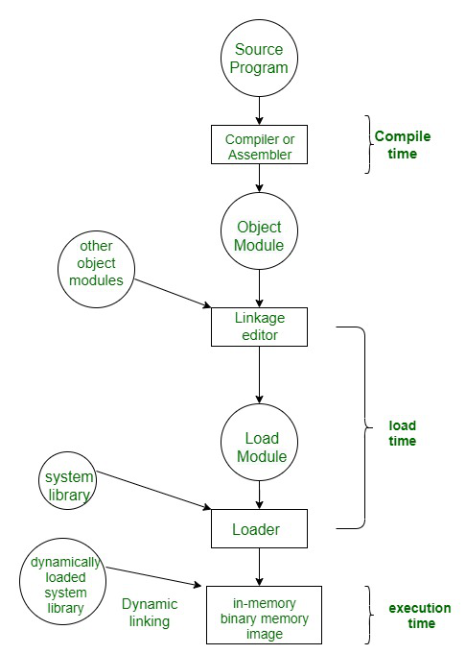

**Mapping Virtual Addresses to Physical Addresses :**  
In Contiguous memory allocation mapping from virtual addresses to physical addresses is not a difficult task, because if we take a process from secondary memory and copy it to the main memory, the addresses  will be stored in a contiguous manner, so if we know the base address of the process, we can find out the next addresses.

The Memory Management Unit is a combination of 2 registers –

1. Base Register (Relocation Register)
2. Limit Register.

**Base Register –**contains the starting physical address of the process.  
**Limit Register** -mentions the limit relative to the base address on the region occupied by the process.

The logical address generated by the CPU is first checked by the limit register, If the value of the logical address generated is less than the value of the limit register, the base address stored in the relocation register is added to the logical address to get the physical address of the memory location.  
If the logical address value is greater than the limit register, then the CPU traps to the OS, and the OS terminates the program by giving fatal error.

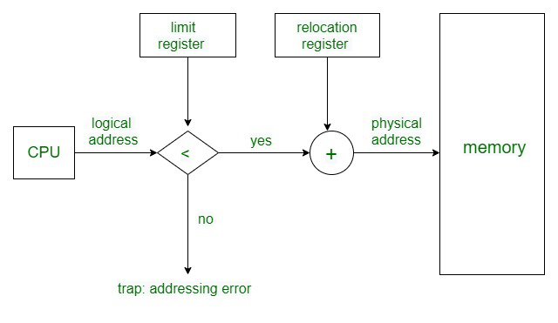

In Non Contiguous Memory allocation, processes can be allocated anywhere in available space. The address translation in non-contiguous memory allocation is difficult.  
There are several techniques used for address translation in non contiguous memory allocation like [Paging](https://www.geeksforgeeks.org/paging-in-operating-system/), [Multitlevel paging](https://www.geeksforgeeks.org/multilevel-paging-in-operating-system/),[Inverted paging](https://www.geeksforgeeks.org/inverted-page-table-in-operating-system/), [Segmentation](https://www.geeksforgeeks.org/segmentation-in-operating-system/), [Segmented paging](https://www.geeksforgeeks.org/paged-segmentation-and-segmented-paging/). Different data structures and hardware support like TLB are required in these techniques.